Speaking Cedi: AI Financial Assistant
Speaking Cedi is a Telegram-based bot designed to capture financial entries in real-time. It uses AI to parse natural language, providing users with instant advice on budgeting, spending, and saving while logging every transaction to a centralized database.
Project Overview
The goal was to create a "frictionless" way to track money. Instead of opening a complex spreadsheet, I can simply text my bot.
The Stack
- The "Face": Telegram (via BotFather) – Provides the user interface.
- The "Brain": OpenAI API (GPT-4o-mini) – Processes text into structured data.
- The "Home": PythonAnywhere – Hosts the script for 24/7 uptime.
- The "Memory": Google Sheets API – Acts as a lightweight database for logging expenses.

Implementation Journey
Phase 1: Identity & Infrastructure
- Bot Creation: Registered the bot with BotFather on Telegram.
  - Name: Speaking Cedi
  - Username: @SpeakingCediBot
- Environment Setup: Configured a Python environment on PythonAnywhere.
  - Self-Correction: I used a Bash Console (used for system commands and installing libraries) rather than a Python Console (used for running live Python code snippets).
- Dependencies: Installed essential libraries for Telegram communication and OpenAI integration.
Phase 2: Intelligence Integration
I connected the script to GPT-4o-mini. The bot was instructed to act as a financial advisor that extracts transaction details from casual messages. At this stage, the bot could successfully answer "Who are you?" and engage in basic conversation.
Phase 3: The Data Pipeline (Google Sheets)
To make the data useful, I integrated Google Sheets:
- Created a project in Google Cloud Console and enabled the Google Drive and Sheets APIs.
- Generated a Service Account JSON key to allow the Python script to log in securely.
- Shared the target Google Sheet with the Service Account email as an "Editor."

Troubleshooting & Debugging
The "Chatty AI" JSON Error
During testing, I encountered a persistent error:
Expecting value: line 1 column 1 (char 0)
The Root Cause: The Python script expected a clean JSON object (e.g., {"amount": 40}) to send to the spreadsheet. However, the AI was being "too polite." It would reply: "Sure! I've logged that for you: {"amount": 40}".
The script would "trip" on the first letter ("S") because it wasn't a curly bracket.
The Solution: I had two paths:
- Optimize the Code: Write a "regex" (regular expression) to find and extract the brackets from the text.
- Optimize the Prompt: Strict System Instructions.
For the MVP (Minimum Viable Product), I chose Option 2. I refined the System Instructions to force the AI to return only the data without conversational filler.
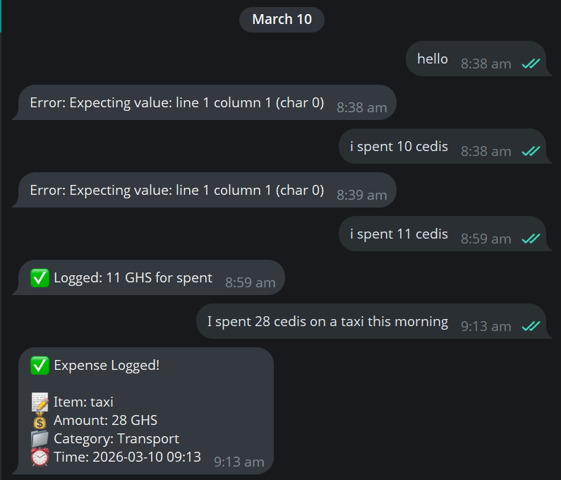
Current Status
Speaking Cedi is live! The bot successfully translates human text into spreadsheet entries, making financial tracking as easy as sending a text message.

